Case Stude

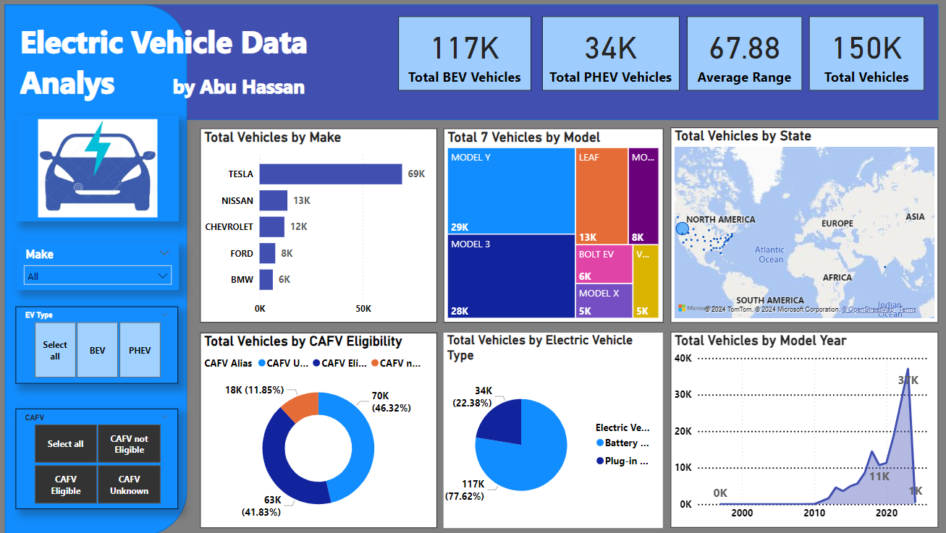

**Overview of the project**

This is one of my Portfolio projects where I have analysis data of Electric Vehicles in USA to find the trends and insights of these vehicles in future. In my analysis I have concentrated on the popularity of EV models in terms of different influencing factors, geographic distribution, and sales.

**PROBLEM STATEMENT**

**KPI’S Requirement**

Total Vehicles:

* Understand the overall landscape of electric vehicles, encompassing both BEVs and PHEVs, to assess the market's size and growth.

2. Average Electric Range:

* Determine the average electric range of the electric vehicles in the dataset to gauge the technological advancements and efficiency of the EVs.

3. Total BEV Vehicles and % of Total BEV Vehicles:

* Identify and analyze the total number of Battery Electric Vehicles (BEVs) in the dataset.
* Calculate the percentage of BEVs relative to the total number of electric vehicles, providing insight into the dominance of fully electric models.

4. Total PHEV Vehicles and % of Total PHEV Vehicles:

* Identify and analyze the total number of Plug-in Hybrid Electric Vehicles (PHEVs) in the dataset.
* Calculate the percentage of PHEVs relative to the total number of electric vehicles, offering insights into the market share of plug-in hybrid models.

**Charts Requirement**

1.Total Vehicles by Model Year (From 2010 Onwards):

* Visualization: Line/ Area Chart
* Description: This chart will illustrate the distribution of electric vehicles over the years, starting from 2010, providing insights into the growth pattern and adoption trends.

2. Total Vehicles by State:

* Visualization: Map Chart
* Description: This chart will showcase the geographical distribution of electric vehicles across different states, allowing for the identification of regions with higher adoption rates.

3. Top 10 Total Vehicles by Make:

* Visualization: Bar Chart
* Description: Highlight the top 10 electric vehicle manufacturers based on the total number of vehicles, providing insights into the market dominance of specific brands.

4. Total Vehicles by CAFV Eligibility:

* Visualization: Pie Chart or Donut Chart
* Description: Illustrate the proportion of electric vehicles that are eligible for Clean Alternative Fuel Vehicle (CAFV) incentives, aiding in understanding the impact of incentives on vehicle adoption.

5. Top 10 Total Vehicles by Model:

* Visualization: Tree map
* Description: Highlight the top 10 electric vehicle models based on the total number of vehicles, offering insights into consumer preferences and popular models in the market.

**Data:**

Data collected from publicly available data set from Kaggle, where this specific dataset was shared by the US government for study purposes or to get feedback.

**Tools used in this project:**

**MySQL**

**Excel**

**Power Query**

**Power BI**

**Data Cleaning:**

I have downloaded file <Electric_Vehicle_Population_Data.csv> into MySQL to do analysis and cleaning.

**Data Processing and Analysis:**

For data processing I have used Power Query tools and ran the following queries.

**Filtering BEV Vehicles**

Total BEV Vehicles = CALCULATE(COUNT(Electric_Vehicle_Population_Data[Electric Vehicle Type]),FILTER(Electric_Vehicle_Population_Data,Electric_Vehicle_Population_Data[Electric Vehicle Type]="Battery Electric Vehicle (BEV)"))

**Filtering PHEV Vehicles**

Total PHEV Vehicles = CALCULATE(COUNT(Electric_Vehicle_Population_Data[Electric Vehicle Type]),FILTER(Electric_Vehicle_Population_Data,Electric_Vehicle_Population_Data[Electric Vehicle Type]="Plug-in Hybrid Electric Vehicle (PHEV)"))

Average Range = AVERAGE(Electric_Vehicle_Population_Data[Electric Range])

Total Vehicles = DISTINCTCOUNT(Electric_Vehicle_Population_Data[DOL Vehicle ID])

Adding a new column for presentation purposes. Changing column name from "Clean Alternative Fuel Vehicle Eligible" to "CAFV Alias".

**Using switch function to do Alias.**

CAFV Alias = SWITCH(Electric_Vehicle_Population_Data[Clean Alternative Fuel Vehicle (CAFV) Eligibility],"Clean Alternative Fuel Vehicle Eligible","CAFV Eligible","Not eligible due to low battery range","CAFV not Eligible","Eligibility unknown as battery range has not been researched","CAFV Unknown",Electric_Vehicle_Population_Data[Clean Alternative Fuel Vehicle (CAFV) Eligibility])

**Adding one more ALIAS column for Vehicle type**

EV Type Alias = SWITCH(Electric_Vehicle_Population_Data[Electric Vehicle Type],"Battery Electric Vehicle (BEV)","BEV","Plug-in Hybrid Electric Vehicle (PHEV)","PHEV",Electric_Vehicle_Population_Data[Electric Vehicle Type])

**Observation**

Insights reveal that there are huge potential growth opportunities for Battery Electric Vehicles. Based on MSRP, Tesla occupies 64% of the market. In USA, Washington is the only state that occupies 99.98% of the EV vehicles. Model 3 OF Tesla sold the most about 69K. All the vehicles Tesla built in Battery Electric Vehicle have an average range 90.30 miles. Tesla AND Nissan are only making Battery Electric Vehicles which is 77.62% of the total Electric Vehicle production in the USA.